**NAME : SAMIRAN DEY**

**ID : 181001002076**

**BATCH : BCS3A**

**SEMESTER: 6TH**

**SUBJECT : WEB TECHNOLOGY**

**LAB PROJECT REPORT**

**CONTENTS**

1. Student-page.html
2. index.html
3. sreg.html
4. admin-page.html
5. alogin.html
6. insert.html
7. update.html
8. about.html
9. contact.html
10. c.css
11. welcome.css
12. alogin.css
13. Hostel.java
14. a.jpg
15. login.jpg
16. logo.jpg
17. sbg2.jpg

**HTML PAGES:**

**index.html**

<html>

<head>

<style>

body {

background-image: url('a.jpg');

}

</style>

<title>WELCOME</title>

<link rel="stylesheet" type="text/css" href="welcome.css">

</head>

<body>

<img src="logo.jpg" style="float:left; height:140px; width: 300px;padding-top: 1px; padding-left: 10px; ">

<h1>WELCOME TO SAM'S HOSTEL</h1>

<ul>

<li><a href="Welcome.html">Home</a></li>

<li><a href="contact.html">Contact</a></li>

<li><a href="about.html">About</a></li>

<li><a href="admin-page.html">Admin-Login</a></li>

<li><a href="Student-page.html">Student Login</a></li>

</ul>

<br>

<div class="login">

</div>

</body>

</html>

**Student-page.html**

<html>

<head>

<style>

body {

background-image: url('a.jpg');

}

</style>

<title>Student Login Page</title>

<link rel="stylesheet" type="text/css" href="c.css">

</head>

<body>

<img src="logo.jpg" style="float:left; height:130px; width: 300px;padding-top: 1px; padding-left: 10px; "> <h1>STUDENT LOGIN PAGE</h1>

<ul>

<li><a href="Welcome.html">Home</a></li>

<li><a href="contact.html">Contact</a></li>

<li><a href="about.html">About</a></li>

<li><a href="admin-page.html">Admin-Login</a></li>

<li><a href="Student-page.html">Student Login</a></li>

</ul>

<br><br>

<div class="login">

<form action="Hostel" method="POST">

<label><b>User Name

</b>

</label>

<input type="text" name="Uname" id="Uname" placeholder="Username" required>

<br><br>

<label><b>Password

</b>

</label>

<input type="Password" name="Pass" id="Pass" placeholder="Password" required>

<br><br>

<input type="submit" name="submit" id="log" value="LOG IN">

<br>

<input type="checkbox" id="check">

<span>Remember me</span>

<a href="#">Forgot Password</a><br></form>

<form action="sreg.html"><input type="submit" name="submit" id="log" value="SIGN UP"></form>

</div>

</body>

</html>

**sreg.html**

<html>

<head>

<style>

body {

background-image: url('a.jpg');

}

</style>

<title>STUDENT REGISTRATION PAGE</title>

<link rel="stylesheet" type="text/css" href="alogin.css">

</head>

<body>

<form action="Hostel" method="POST">

<h1>STUDENT REGISTRATION PAGE</h1>

<ul>

<li><a href="Welcome.html">Home</a></li>

<li><a href="contact.html">Contact</a></li>

<li><a href="about.html">About</a></li>

<li><a href="admin-page.html">Admin-Login</a></li>

<li><a href="Student-page.html">Student Login</a></li>

</ul>

<br><br>

<div class="login">

<label><b>Name: </b> </label> <br>

<input type="text" name="Fname" id="Fname" placeholder="Firstname" required>

<br><br>

<label><b>User Name: </b> </label> <br>

<input type="text" name="Uname" id="Uname" placeholder="UserName" required>

<br><br>

<label><b>Password: </b> </label> <br>

<input type="Password" name="Pass" id="Pass" placeholder="Password" required>

<br><br>

<input type="checkbox" id="check">

<span>Remember me</span> <br>

<input type="submit" name="submit" id="log" value="SIGN UP"></form>

</div>

</body>

</html>

**admin-page.html**

<html>

<head>

<style>

body {

background-image: url('a.jpg');

}</style>

<title>ADMIN Login Form</title>

<link rel="stylesheet" type="text/css" href="c.css">

</head>

<body>

<form action="Hostel" method="POST">

<img src="logo.jpg" style="float:left; height:130px; width: 300px;padding-top: 1px; padding-left: 10px; ">

<h1>ADMIN LOGIN PAGE</h1>

<ul>

<li><a href="Welcome.html">Home</a></li>

<li><a href="contact.html">Contact</a></li>

<li><a href="about.html">About</a></li>

<li><a href="admin-page.html">Admin-Login</a></li>

<li><a href="Student-page.html">Student Login</a></li>

</ul><br><br>

<div class="login">

<label><b>User Name

</b>

</label>

<input type="text" name="Uname" id="Uname" placeholder="Username" required>

<br><br>

<label><b>Password

</b>

</label>

<input type="Password" name="Pass" id="Pass" placeholder="Password" required>

<br><br>

<input type="submit" name="submit" id="log" value="ADMIN-LOGIN"> <br>

<input type="checkbox" id="check">

<span>Remember me</span>

<a href="#">Forgot Password</a><br><br> </form>

</div>

</body>

</html>

**alogin.html**

<html>

<head>

<style>

body {

background-image: url('alogin.jpg');

}

</style>

<title>ADMIN LOGIN</title>

<link rel="stylesheet" type="text/css" href="alogin.css">

</head>

<body>

<h1>ADMIN ACCESS</h1>

<ul>

<li><a href="Welcome.html">LOGOUT</a></li>

<li><a href="admin-page.html">Admin-Login</a></li>

<li><a href="Student-page.html">Student Login</a></li>

<li><a href="insert.html">INSERT</a></li>

<li><a href="update.html">UPDATE</a></li>

<li><a href="">DELETE</a></li>

<li><a href="Welcome.html">HOME</a></li>

</ul>

<table>

<caption><b>CHECK IN TABLE</b></caption>

<tr>

<th>#ID</th>

<th>TYPE</th>

<th>LOCATION</th>

<th>CHARGE</th>

<th>ROOM STATUS</th>

<th>PAYMENT STATUS</th>

</tr>

</table>

</body>

</html>

**insert.html**

<html>

<head>

<style>

body {

background-image: url('alogin.jpg');

}

</style>

<title>INSERT PAGE</title>

<link rel="stylesheet" type="text/css" href="alogin.css">

</head>

<body>

<form action="Hostel" method="POST">

<h1>CREATE ROOM</h1>

<ul>

<li><a href="Welcome.html">Home</a></li>

<li><a href="alogin.html">Admin Login</a></li>

</ul>

<br><br>

<div class="login">

<label><b>ROOM ID</b></label><br>

<input type="text" name="RI" id="RI" placeholder="ROOM ID" required>

<br>

<label><b>ROOM TYPE</b></label><br>

<select id="select" name="RT">

<option>Single</option>

<option>Double</option>

<option>Single AC</option>

<option>Double AC</option>

</select>

<br>

<label><b>ROOM LOCATION</b></label><br>

<input type="text" name="RL" id="RL" placeholder="ROOM LOCATION" required>

<br>

<label><b>ROOM CHARGES</b></label><br>

<input type="text" name="RC" id="RC" placeholder="ROOM CHARGES" required>

<br><br>

<input type="submit" name="submit" id="log" value="INSERT">

<br>

</form>

</div>

</body>

</html>

**update.html**

<html>

<head>

<style>

body {

background-image: url('alogin.jpg');

}

</style>

<title>UPDATE PAGE</title>

<link rel="stylesheet" type="text/css" href="alogin.css">

</head>

<body>

<form action="Hostel" method="POST">

<h1>UPDATE ROOM</h1>

<ul>

<li><a href="Welcome.html">Home</a></li>

<li><a href="alogin.html">Admin Login</a></li>

</ul>

<br><br>

<div class="login">

<label><b>ROOM ID</b></label><br>

<input type="text" name="RI" id="RI" placeholder="ROOM ID" required>

<br> <br>

<label><b>ROOM TYPE</b></label><br>

<select id="select" name="RT">

<option>Single</option>

<option>Double</option>

<option>Single AC</option>

<option>Double AC</option>

</select>

<br><br>

<label><b>ROOM LOCATION</b></label><br>

<input type="text" name="RL" id="RL" placeholder="ROOM LOCATION" required>

<br><br>

<label><b>ROOM CHARGES</b></label><br>

<input type="text" name="RC" id="RC" placeholder="ROOM CHARGES" required>

<br><br>

<input type="submit" name="submit" id="log" value="UPDATE">

<br>

</form>

</div>

</body>

</html>

**about.html**

<html>

<head>

<style>

body {

background-image: url('a.jpg');

}

</style>

<title>WELCOME</title>

<link rel="stylesheet" type="text/css" href="welcome.css">

</head>

<body>

<img src="logo.jpg" style="float:left; height:140px; width: 300px;padding-top: 1px; padding-left: 10px; ">

<h1>ABOUT SAM'S HOSTEL</h1>

<ul>

<li><a href="Welcome.html">Home</a></li>

<li><a href="contact.html">Contact</a></li>

<li><a href="about.html">About</a></li>

<li><a href="admin-page.html">Admin-Login</a></li>

<li><a href="Student-page.html">Student Login</a></li>

</ul>

<br>

<div class="login">

<p><h3><b> Hostel Management System is software that is developed to help in managing various activities in the hostel. As is well-known, the education institutions are rapidly increasing for the past few years.

Therefore, it leads to mushrooming of hostels for the accommodation of the students study in these institutions. And hence there is the appearance of Hostel Management System which helps with dealing the problem of managing hostel and avoid the problem when do it manually.

Hostel management by manual way is tedious process, since it involves work load and time consumption.

In this system, we can easily manage the hostel details, room details, student records, mess expenditure, mess bill calculation, easy way of room allocation and hostel attendance.

Thus, there are a lot of repetition can be easily evaded which has reduced the data redundancy.</b></h3></p>

</div>

</body>

</html>

**contact.html**

<html>

<head>

<title>CONTACT US</title>

<link rel="stylesheet" type="text/css" href="welcome.css">

</head>

<body>

<div class="container">

<form action="">

<label for="fname">First Name</label><br><br>

<input type="text" id="f" name="firstname" placeholder="Your name.."><br><br>

<label for="lname">Last Name</label><br><br>

<input type="text" id="l" name="lastname" placeholder="Your last name.."><br><br>

<label for="country">Country</label><br><br>

<select id="country" name="country">

<option value="australia">Australia</option>

<option value="canada">Canada</option>

<option value="usa">USA</option>

</select>

<br><br><label for="subject">Subject</label>

<textarea id="subject" name="subject" placeholder="Write something.." style="height:200px"></textarea>

<input type="submit" value="Submit">

</form>

</div>

</body>

</html>

**.CSS FILES**

**welcome.css**

body

{

margin: 0;

padding: 0;

/*background-color:#fc0373; */

font-family: 'Arial';

}

h3{

border-style:solid;

}

img {

opacity: 1.0;

margin-top:5px;

}

h1{

border-style: solid;

border-radius: 13px;

width: 40%;

margin-left: 500px;

margin-top:20px;

background-color:skyblue;

color:black;

opacity:0.7;

padding-left: 50px;

}

ul {

list-style-type: none;

margin: 0;

padding: 0;

overflow: hidden;

background-color:#2bbded;

opacity: 0.7;

font-weight: bold;

}

li {

border-right: 1px solid #bbb;

}

li a {

border-right: 1px solid #bbb;

display: block;

color: black;

text-align: center;

padding: 14px 16px;

font-size: 20px;

text-decoration: underline;

}

li a:hover {

background-color: white;

color: black;

}

label{

color: #00accf;

font-size: 20px;

}

#Uname{

width: 400px;

height: 40px;

border: none;

border-radius: 3px;

padding-left: 8px;

}

#Pass{

width: 400px;

height: 40px;

border: none;

border-radius: 3px;

padding-left: 8px;

}

#log{

width: 200px;

height: 30px;

border: none;

border-radius: 17px;

padding-left: 7px;

background: #00accf;

color:white;

}

span{

color: darkblue;

font-size: 17px;

}

table{

margin-left: 350px;

margin-top: 120px;

border-collapse: collapse;

width: 50%;

text-align: left;

opacity:0.88;

}

table a{

background-color: white;

}

th {

background-color:#001329;

color: white;

border-bottom:3px solid #001329;

padding: 8px;

}

td {

background-color:white;

color: black;

padding: 8px;

border-bottom:3px solid #001329;

}

a{

float: right;

background-color:#2bbded;

}

#alog{

width: 200px;

height: 30px;

border: none;

border-radius: 17px;

padding-left: 7px;

background: #fa5a5a;

color:white;

}

input[type=text], select, textarea {

width: 100%; /* Full width */

padding: 12px; /* Some padding */

border: 1px solid #ccc; /* Gray border */

border-radius: 4px; /* Rounded borders */

box-sizing: border-box; /* Make sure that padding and width stays in place */

margin-top: 6px; /* Add a top margin */

margin-bottom: 16px; /* Bottom margin */

resize: vertical /* Allow the user to vertically resize the textarea (not horizontally) */

}

input[type=submit] {

background-color: #04AA6D;

color: white;

padding: 12px 20px;

border: none;

border-radius: 4px;

cursor: pointer;

}

input[type=submit]:hover {

background-color: #45a049;

}

.container {

border-radius: 5px;

background-color: #f2f2f2;

padding: 20px;

}

**c.css**

body

{

margin: 0;

padding: 0;

/*background-color:#fc0373; */

font-family: 'Arial';

}

img {

opacity: 0.8;

}

.login{

opacity: 0.8;

width: 400px;

padding-bottom: 50px;

overflow: hidden;

margin: auto;

padding: 30px;

background: #aeb5b0;

border-radius: 15px ;

}

h1{

text-align:center;

border-style: solid;

border-radius: 13px;

width: 40%;

margin-left: 500px;

margin-top:20px;

background-color:whitesmoke;

color:black;

opacity:0.7;

padding-left:1px;

}

ul {

list-style-type: none;

margin: 0;

padding: 0;

overflow: hidden;

background-color: #aeb5b0;

opacity: 0.8;

font-weight: bold;

}

li a {

border-right: 1px solid black;

display: block;

color: black;

text-align: center;

padding: 14px 16px;

text-decoration: underline;

}

li a:hover {

background-color:white;

color:black;

}

label{

color: black;

font-size: 20px;

}

#Uname{

width: 400px;

height: 40px;

border: none;

border-radius: 3px;

padding-left: 8px;

}

#Pass{

width: 400px;

height: 40px;

border: none;

border-radius: 3px;

padding-left: 8px;

}

#log{

width: 200px;

height: 30px;

border: none;

border-radius: 17px;

padding-left: 7px;

background: #2b2d2e;

color:white;

}

span{

color: darkblue;

font-size: 17px;

}

a{

float: right;

background-color:#aeb5b0;

}

#alog{

width: 200px;

height: 30px;

border: none;

border-radius: 17px;

padding-left: 7px;

background: #fa5a5a;

color:white;

}

**alogin.css**

body

{

margin: 0;

padding: 0;

/*background-color:#fc0373; */

font-family: 'Arial';

}

img {

opacity: 0.8;

}

.login{

opacity: 0.8;

width: 400px;

overflow: hidden;

margin: auto;

padding: 40px;

background: #aeb5b0;

border-radius: 15px ;

}

#DEL{

opacity: 0.8;

width: 50px;

overflow: hidden;

border-radius: 5px ;

margin-top:1px;

}

#DRI{

width: 100px;

height: 30px;

border: none;

border-radius: 3px;

padding-left: 8px;

}

#del{

width: 100px;

opacity: 0.8;

border-radius: 17px;

padding-right: 6px;

padding-left: 7px;

padding-top: 7px;

padding-bottom:10px;

background-color: black;

color: white;

}

h1{

text-align: center;

color: black;

font-weight: bold;

border-style: solid;

border-radius: 13px;

width: 40%;

margin-left: 370px;

margin-top:20px;

background-color: whitesmoke;

opacity:0.7;

padding-left: 10px;

}

ul {

list-style-type: none;

margin: 0;

padding: 0;

overflow: hidden;

background-color: black;

opacity: 0.8;

font-weight: bold;

}

li a {

border-right: 1px solid white;

display: block;

color:white;

text-align: center;

padding: 14px 16px;

text-decoration: underline;

}

li a:hover {

background-color:white;

color:black;

}

#log{

width: 200px;

height: 30px;

border: none;

border-radius: 17px;

padding-left: 7px;

background: black;

color:white;

}

#select{

width: 400px;

height: 30px;

border: none;

border-radius: 3px;

padding-left: 8px;

}

#RI{

width: 400px;

height: 30px;

border: none;

border-radius: 3px;

padding-left: 8px;

}

#RT{

width: 400px;

height: 30px;

border: none;

border-radius: 3px;

padding-left: 8px;

}

#RL{

width: 400px;

height: 30px;

border: none;

border-radius: 3px;

padding-left: 8px;

}

#RC{

width: 400px;

height: 30px;

border: none;

border-radius: 3px;

padding-left: 8px;

}

#Fname{

width: 400px;

height: 30px;

border: none;

border-radius: 3px;

padding-left: 8px;

}

#Lname{

width: 400px;

height: 30px;

border: none;

border-radius: 3px;

padding-left: 8px;

}

#Uname{

width: 400px;

height: 30px;

border: none;

border-radius: 3px;

padding-left: 8px;

}

#Pass{

width: 400px;

height: 30px;

border: none;

border-radius: 3px;

padding-left: 8px;

}

span{

color: darkblue;

font-size: 17px;

}

table{

margin-left: 300px;

margin-top: 90px;

border-collapse: collapse;

width: 50%;

text-align: left;

opacity:0.88;

}

table a{

background-color: white;

}

caption{

background-color:black;

color:white;

text-decoration: underline;

}

th {

background-color:#001329;

color: white;

border-bottom:3px solid #001329;

padding: 5px;

}

td {

background-color:white;

color: black;

padding: 8px;

border-bottom:3px solid #001329;

}

a{

float: right;

background-color: black;

}

**JAVA SERVLET CODE:**

**Hostel.java**

/*

* To change this license header, choose License Headers in Project Properties.

* To change this template file, choose Tools | Templates

* and open the template in the editor.

*/

package Hostel;

import java.io.*;

import java.io.PrintWriter;

import jakarta.servlet.annotation.WebServlet;

import jakarta.servlet.ServletException;

import jakarta.servlet.http.HttpServlet;

import jakarta.servlet.http.HttpServletRequest;

import jakarta.servlet.http.HttpServletResponse;

import java.util.ArrayList;

/**

*

* @Samiran

*/

@WebServlet(name = "Hostel", urlPatterns = {"/Hostel"})

public class Hostel extends HttpServlet//hostel-sservlet

{

static ArrayList std_name=new ArrayList();//STUDENT REGISTRATION

static ArrayList std_id=new ArrayList();

static ArrayList std_pwd=new ArrayList();

static ArrayList room=new ArrayList();//STORING ROOM VALUES

static String statusid="";

static String hellostatus="";

String name,id,pwd;

static int f;

//ADMIN FUNCTIONS

public void doGetA(HttpServletRequest req, HttpServletResponse res) throws ServletException, IOException

{

res.setContentType("text/html");

PrintWriter pw = res.getWriter();

pw.println("<html> \n" +

"<head> \n" +

"<style>\n" +

"body {\n" +

" background-image: url('alogin.jpg');\n" +

"}\n" +

"</style>\n" +

" <title>ADMIN LOGIN</title> \n" +

" <link rel=\"stylesheet\" type=\"text/css\" href=\"alogin.css\"> \n" +

"</head> \n" +

"<body> \n" +

" \n" +

" <h1>ADMIN ACCESS</h1>\n" +

"<ul>\n" +

" <li><a href=\"Welcome.html\">LOGOUT</a></li>\n" +

" <li><a href=\"admin-page.html\">Admin-Login</a></li>\n" +

" <li><a href=\"Student-page.html\">Student Login</a></li>\n" +

" <li><a href=\"insert.html\">INSERT</a></li>\n" +

" <li><a href=\"update.html\">UPDATE</a></li>\n" +

" <li><a href=\"#\" onclick=\"fun()\">DELETE</a></li>\n" +

" <li><a href=\"Welcome.html\">HOME</a></li>\n" +

" \n" +

"</ul>\n" +

" \n" +

"<table>\n" +

" <caption><b>CHECK IN TABLE</b></caption>\n" +

"<tr>\n" +

" <th>#ID</th>\n" +

" <th>TYPE</th>\n" +

" <th>LOCATION</th>\n" +

" <th>CHARGE</th>\n" +

" <th>ROOM STATUS</th>\n" +

" <th>PAYMENT STATUS</th>\n" +

" \n" +

"</tr>");

for(int i=0;i<room.size();)

{

pw.println(" <tr>\n" +

" <td>"+room.get(i)+" </td>\n" +

" <td> "+room.get(i+1)+"</td>\n" +

" <td> "+room.get(i+2)+"</td>\n" +

" <td> "+room.get(i+3)+"</td>\n" +

" <td> "+room.get(i+4)+"</td>\n" +

" <td>Not Paid</td>\n" +" \n" +

" </tr>");

i=i+5;

}

//DELETE BUTTON

pw.println(

" </table>\n" +

"<div class=\"login\" id=\"DEL\"> \n" +

" \n" +

" <form action=\"Hostel\" method=\"POST\"> \n" +

" <label><b>ROOM ID</b></label><br> \n" +

" <input type=\"text\" name=\"DRI\" id=\"DRI\" placeholder=\"ROOM ID\" > <br> \n " +

" <input type=\"submit\" name=\"submit\" id=\"del\" value=\"DELETE\" style=\"margin-top:5px;\">\n" +

" </form>\n" +

" \n" +

"</div>\n" +

"<script>document.getElementById(\"DEL\").style.display=\"none\";\n" +

"function fun(){\n" +//DISPLAYING DELETE BUTTON

" document.getElementById(\"DEL\").style.display=\"block\"; \n" +

"}\n" +

"</script>" +

"</body>\n" +

"</html>");

}

//STUDENT TABLE

public void doGetSt(HttpServletRequest req, HttpServletResponse res) throws ServletException, IOException

{

res.setContentType("text/html");

PrintWriter pw = res.getWriter();

pw.println("<html>\n" +

"<head>\n" +

"<style>\n" +

"body {\n" +

" background-image: url('sbg2.jpg');\n" +

"}\n" +

"</style>\n" +

" <title>CheckIn Table</title>\n" +

"<link rel=\"stylesheet\" type=\"text/css\" href=\"welcome.css\"> \n" +

"</head>\n" +

"<body>\n" +

"\n" +

"<ul>\n" +

" <li><a href=\"Welcome.html\">LOGOUT</a></li>\n" +

" <li><a href=\"admin-page.html\">Admin-Login</a></li>\n" +

" <li><a href=\"Student-page.html\">Student Login</a></li>\n" +

" <li><a href=\"#\"> <form action=\"Hostel\" method=\"POST\"><button type=\"submit\" name=\"submit\" value=\"Checkin\" style=\"background-color:#2bbded; border:none; font-weight:bold; font-size:20px; text-decoration: underline;\" >AVAILABLE ROOMS</button></form></a></li>\n" +

" <li><a href=\"Welcome.html\">HOME</a></li>\n" +

" \n" +

"</ul>\n" +"<h2><p style=\"margin-left:30px;\"><b>Hello </b>"+hellostatus+",</p></h2>"+

"\n" +

"<table >\n" +

" <caption><b>CHECK IN TABLE</b></caption>\n" +

"<tr>\n" +

" <th>#ID</th>\n" +

" <th>TYPE</th>\n" +

" <th>LOCATION</th>\n" +

" <th>CHARGE</th>\n" +

" <th>PAYMENT STATUS</th>\n" +

" <th>CHECKOUT</th>\n" +

" \n" +

"</tr>");

for(int i=0;i<room.size();)

{

if(statusid.equals(room.get(i+4))){

pw.println(" <tr>\n" +

" <td>"+room.get(i)+" </td>\n" +

" <td> "+room.get(i+1)+"</td>\n" +

" <td> "+room.get(i+2)+"</td>\n" +

" <td> "+room.get(i+3)+"</td>\n" +

" <td>Not Paid</td>\n" +

" <td><a href=\"#\"><form action=\"Hostel\" method=\"POST\"><button type=\"submit\" name=\"submit\" value=\"checkout"+room.get(i)+"\" style=\"background-color:#2bbded; border:none; font-weight:bold; font-size:20px; text-decoration: underline;\">Checkout</button></form></a></td>\n" +

" </tr>\n" );

}

i=i+5;}

pw.println(

" </table>\n" +

"</body>\n" +

"</html>");

}

public void doGetSRA(HttpServletRequest req, HttpServletResponse res) throws ServletException, IOException

{

res.setContentType("text/html");

PrintWriter pw = res.getWriter();

pw.println("<html>\n" +

"<head>\n" +

"<style>\n" +

"body {\n" +

" background-image: url('sbg2.jpg');\n" +

"}\n" +

"</style>\n" +

" <title>CheckIn Table</title>\n" +

"<link rel=\"stylesheet\" type=\"text/css\" href=\"welcome.css\"> \n" +

"</head>\n" +

"<body>\n" +

"\n" +

"<ul>\n" +

" <li><a href=\"Welcome.html\">LOGOUT</a></li>\n" +

" <li><a href=\"admin-page.html\">Admin-Login</a></li>\n" +

" <li><a href=\"Student-page.html\">Student Login</a></li>\n" +

" <li><a href=\"#\"> <form action=\"Hostel\" method=\"POST\"><button type=\"submit\" name=\"submit\" value=\"Checkin\" style=\"background-color:#2bbded; border:none; font-weight:bold; font-size:20px; text-decoration: underline;\">AVAILABLE ROOMS</button></form></a></li>\n" +

" <li><a href=\"Welcome.html\">HOME</a></li>\n" +

" \n" +

"</ul>" +

"\n" +"\n"+"<h2><p style=\"margin-left:30px;\"><b>Hello </b>"+hellostatus+",</p></h2>"+

"<table >\n" +

" <caption><b>CHECK IN TABLE</b></caption>\n" +

"<tr>\n" +

" <th>#ID</th>\n" +

" <th>TYPE</th>\n" +

" <th>LOCATION</th>\n" +

" <th>CHARGE</th>\n" +

" <th>PAYMENT STATUS</th>\n" +

" <th>CHECK IN</th>\n" +

" \n" +

"</tr>");

int j=0;

for(int i=0;i<room.size();)

{

if(room.get(i+4).equals("Available"))

{

pw.println(" <tr>\n" +

" <td>"+room.get(i)+" </td>\n" +

" <td> "+room.get(i+1)+"</td>\n" +

" <td> "+room.get(i+2)+"</td>\n" +

" <td> "+room.get(i+3)+"</td>\n" +

" <td>Not Paid</td>\n" +

"<td><a href=\"#\"><form action=\"Hostel\" method=\"POST\"><button type=\"submit\" class=\"mybutton\" name=\"submit\" value=\"check-in"+j+"\" style=\"background-color:#2bbded; border:none; font-weight:bold; font-size:20px; text-decoration: underline;\">CHECK-IN</button></form></a></td>\n" +

" \n" +

" </tr>");

}

i=i+5;

j++; //to get the exact indexes of rooms available

}

pw.println(

"</table>\n" +

"\n" +

"</body>\n" +

"</html>\n" +

"\n" +

"");

}

public void doGet(HttpServletRequest req, HttpServletResponse res) throws ServletException, IOException

{

res.setContentType("text/html");

PrintWriter pw = res.getWriter();

String chk_btn=req.getParameter("submit");//VALUE OF CLICKED PARAM

if(chk_btn.equals("SIGN UP"))//STUDENT REGISTRATION

{

f=1;

name = req.getParameter("Fname");

id= req.getParameter("Uname");

pwd= req.getParameter("Pass");

res.sendRedirect("Student-page.html");

}

else if(chk_btn.equals("LOG IN"))//STUDENT SIGN IN

{

String id= req.getParameter("Uname");

String pwd= req.getParameter("Pass");

int c=0;

if(id.equalsIgnoreCase("Sam") && pwd.equals("1234"))

{

c=2;

statusid=" Taken by "+id;

hellostatus =id;

doGetSt(req,res);

}

else if(c!=2)

{

for(int i=0;i<std_id.size();i++)

{

if(id.equals(std_id.get(i)) && pwd.equals(std_pwd.get(i)))

{

c=1;

statusid=" Taken by "+id;

hellostatus=id;

doGetSt(req,res);//FUNCTION CALL

}

}

}

if(c==0)

{

pw.println("<html>\n" +

" \n" +

" <body>\n" +

" <script>\n" +

" alert(\"INVALID USERNAME or Password\");\n" +

"location.replace(\"Student-page.html\")\n"+

" </script>\n" +

" </body>\n" +

" \n" +

"</html>");

}

}

else if(chk_btn.equals("ADMIN-LOGIN"))//ADMIN SIGN IN

{

String usr= req.getParameter("Uname");

String pwd= req.getParameter("Pass");

if(usr.equalsIgnoreCase("admin") && pwd.equals("1234"))

{

doGetA(req,res);

}

else

{

pw.println("<html>\n" +

" \n" +

" <body>\n" +

" <script>\n" +

" alert(\"INVALID USERNAME or Password\");\n" +

"location.replace(\"admin-page.html\")\n"+

" </script>\n" +

" </body>\n" +

" \n" +

"</html>");

}

}

else if (chk_btn.equals("INSERT"))//INSERT ROOMS

{

int f = 0;

id = req.getParameter("RI");

pwd = req.getParameter("RT");

String rl = req.getParameter("RL");

String rc = req.getParameter("RC");

for(int i=0;i<room.size();i=i+5)

{

if(id.equals(room.get(i)))

{

f=1;

break;

}

}

if(f==0)

{

room.add(id);

room.add(pwd);

room.add(rl);

room.add(rc);

room.add("Available");

doGetA(req,res);

}

else

{

pw.println("<html>\n" +

" \n" +

" <body>\n" +

" <script>\n" +

" alert(\"ROOM ID EXISTS \");\n" +

"location.replace(\"insert.html\")\n"+

" </script>\n" +

" </body>\n" +

" \n" +

"</html>");

}

}

else if (chk_btn.equals("UPDATE"))//UPDATING ROOMS

{

int c=0;

id = req.getParameter("RI");

pwd = req.getParameter("RT");

String rl = req.getParameter("RL");

String rc = req.getParameter("RC");

for(int i=0;i<room.size();i=i+5)

{

if(id.equals(room.get(i)))//CHECKING ROOM ID EXISTS

{

c=1;

room.set(i,id);

room.set(i+1,pwd);

room.set(i+2,rl);

room.set(i+3,rc);

doGetA(req,res);

}

}

if(c==0)

{

pw.println("<html>\n" +

" \n" +

" <body>\n" +

" <script>\n" +

" alert(\"ROOM ID DOES NOT EXISTS\");\n" +

"location.replace(\"update.html\")\n"+

" </script>\n" +

" </body>\n" +

" \n" +

"</html>");

}

}

else if(chk_btn.equals("DELETE"))//DELETING ROOMS

{

id = req.getParameter("DRI");

int c=0;

for(int i=0;i<room.size();i=i+5)//TO REMOVE ALL THE ELEMENTS IN THAT ROW

{

if(id.equals(room.get(i)))

{

c=1;

room.remove(i);

room.remove(i);

room.remove(i);

room.remove(i);

room.remove(i);

break;

}

}

if(c==1)

{

doGetA(req,res);

}

else

{

pw.println("<html>\n" +

" \n" +

" <body>\n" +

" <script>\n" +

" alert(\"Room id does not exist\");\n" +

" </script>\n" +

" </body>\n" +

" \n" +

"</html>");

doGetA(req,res);

}

}

else if(chk_btn.equals("Checkin"))//STUDENT LOBBY TO AVAILABLE ROOM

{

doGetSRA(req,res);

}

else if(chk_btn.startsWith("check-in"))//AVAILABLE ROOM TO STUDENT LOBBY

{

String s=chk_btn.substring(8);//

int n=Integer.parseInt(s);

room.set((n*5)+4,statusid); //accesing 5elements together

doGetSt(req,res);

}

else if(chk_btn.startsWith("checkout"))//STUDENT LOGIN TO STUDENT LOGIN

{

String s=chk_btn.substring(8);

for(int i=0;i<room.size();i=i+5)

{

if(s.equals(room.get(i)))

{

room.set(i+4,"Available");

break;

}

}

doGetSt(req,res);

}

}

public void doPost(HttpServletRequest req, HttpServletResponse res) throws ServletException, IOException

{

PrintWriter pw = res.getWriter();

Hostel ob=new Hostel();//CREATING OBJECTS

ob.doGet(req, res);

if(f==1)

{

f=0; //ADDING DATA INTO LIST

std_name.add(ob.name);

std_id.add(ob.id);

std_pwd.add(ob.pwd);

}

pw.close();

}

}

**BACKGROUND IMAGES USED:**

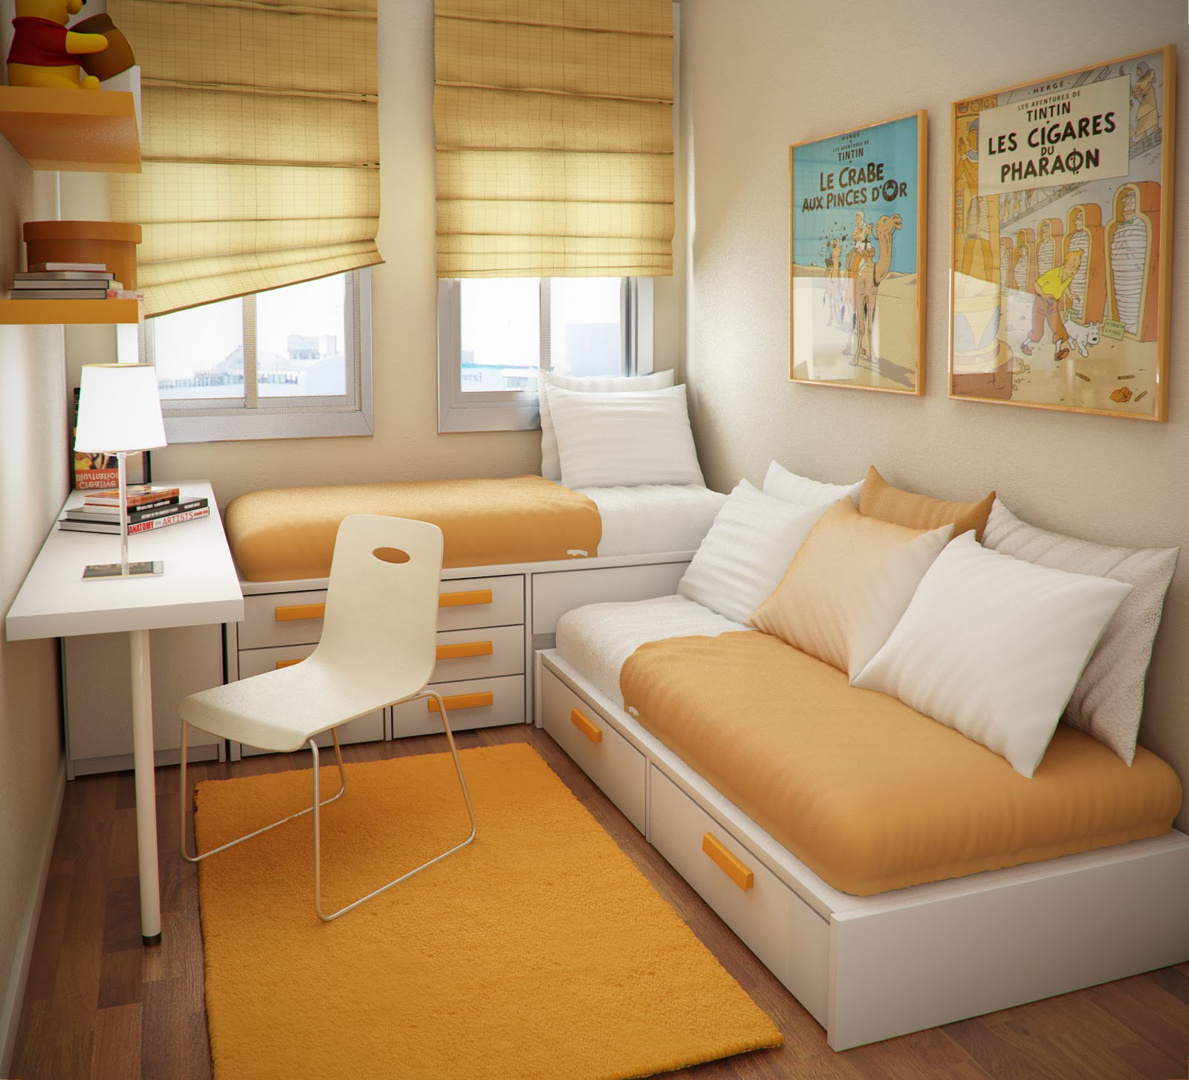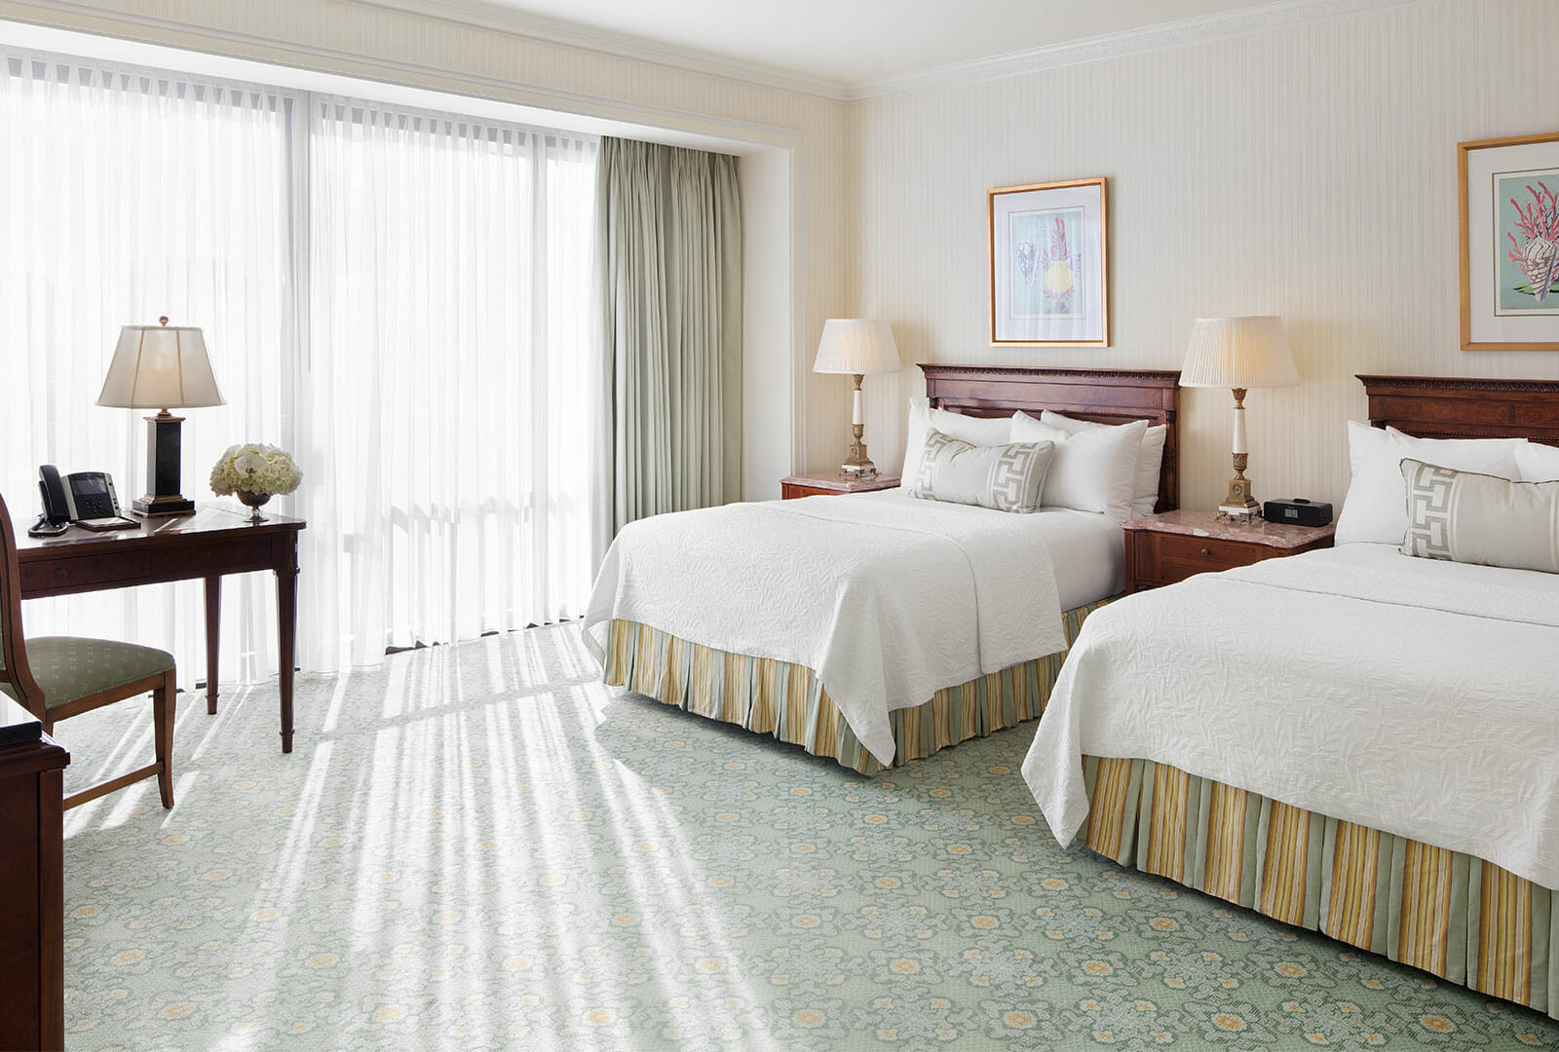

**SCREENSHOTS OF PROJECT:**

